COMPUTER SCIENCE PROJECT
NAME: FALAK MINOCHA
ROLL NO: 26BAI10769
BRANCH: B.Tech CSE AI ML


ULTIMATE QUIZ ARENA
THE ULTIMATE GAME SYSTEM

Name: FALAK MINOCHA
BATCH: 2026-30

S. No. | Description | Page No.
1. | ACKNOWLEDGEMENT | 4
2. | INTRODUCTION | 5
3. | COMMERCIAL SCOPE | 7
4. | FLAWS AND IMPROVEMENT SCOPE
5. | PYTHON FRONT END
6. | PYTHON MODULES
7. | USER DEFINED FUNCTIONS (UDFs)
8. | HARDWARE AND SOFTWARE
9. | GLOSSARY
10. | FLOWCHART
11. | CODE
12. | OUTPUTS
13. | BIBLIOGRAPHY

ACKNOWLEDGEMENT
I would like to express my sincere gratitude to my teacher and institution for providing me with the opportunity to develop this Python project, Ultimate Quiz Arena.
This project helped me understand how different Python programming concepts can be combined to create a complete interactive application. While developing the project, I gained practical experience with functions, loops, conditional statements, dictionaries, lists, user input, randomization, calculations, and time-based programming.
I would also like to thank my teacher for providing guidance and support throughout the development of this project. The project allowed me to apply the concepts learned during the Python course in a practical and interactive manner.
Finally, I am thankful to everyone who supported and encouraged me during the development and testing of the project.
FALAK MINOCHA
26BAI10769

INTRODUCTION
3.1 Project Overview
Ultimate Quiz Arena is an interactive command-line quiz application developed using Python. The main purpose of the project is to combine learning and entertainment through a game-based quiz environment.
The application provides questions from four major subjects:
- Python
- Mathematics
- Science
- General Knowledge
The questions are organized into three difficulty levels:
- Easy
- Medium
- Hard
The project goes beyond a simple question-and-answer program by incorporating several game modes, power-ups, achievements, XP, levels, coins, mini-games, performance statistics, and a session leaderboard.
3.2 Objectives
The major objectives of the project are:
- To create an interactive Python-based quiz application.
- To make learning more engaging through game-based features.
- To provide questions from multiple subjects.
- To introduce different difficulty levels.
- To implement multiple game modes.
- To provide a scoring and reward system.
- To track player progress through XP and levels.
- To implement achievements and streaks.
- To provide mini-games for additional entertainment.
- To demonstrate practical use of Python programming concepts.
3.3 Major Features
The project contains:
- Multiple subjects
- Three difficulty levels
- Multiple quiz modes
- Power-ups and lifelines
- XP and level system
- Coins and Arena Shop
- Streak tracking
- Achievements
- Mini-games
- Performance Lab
- Player Profile
- Session Leaderboard
- Arena Guide
The main menu provides sixteen options covering the different features of the application.
3.4 Project Concept
The project follows a simple cycle:
Start Game → Enter Player Name → Select Feature → Play → Receive Score/XP/Coins → Update Statistics → Continue or Exit
All major player statistics are maintained while the program is running.

COMMERCIAL SCOPE
Ultimate Quiz Arena has potential for development into a larger educational gaming platform.
Although the current project is a command-line Python application, its basic concept can be extended to desktop, web, or mobile platforms.
Possible Commercial Applications
4.1 Educational Platforms
The project could be adapted for schools, colleges, and educational websites where students can practice different subjects through interactive quizzes.
4.2 Competitive Quiz Platforms
A future version could support online competitions, multiplayer matches, tournaments, and permanent leaderboards.
4.3 Learning and Gamification
The XP, levels, coins, achievements, streaks, and rewards system could be expanded into a complete gamified learning platform.
4.4 Online Quiz Services
The project could eventually be converted into a web-based application where users create accounts, participate in quizzes, and track their performance.
4.5 Corporate Training
The same concept could be adapted for employee training, skill assessments, technical quizzes, and certification preparation.
Future Commercial Features
Potential commercial features could include:
- User accounts
- Online database
- Cloud-based leaderboard
- Multiplayer quizzes
- Question management system
- Administrative dashboard
- Online tournaments
- Mobile application
- Subscription-based premium content
These are future possibilities and are not currently implemented in the submitted Python program.

PYTHON: FRONTEND
The front end of the current project is a command-line interface (CLI) developed using Python.
The program displays menus, questions, player statistics, scores, power-ups, achievements, and results directly in the terminal.
6.1 User Interaction
The user interacts with the program using keyboard input.
The program asks the player to:
- Enter their name
- Select menu options
- Select subjects
- Select difficulty
- Answer questions
- Select power-ups
- Play mini-games
6.2 Main Menu
The main menu contains:
- Classic Quiz
- Rapid Fire
- Survival Mode
- Risk & Reward
- Boss Battle
- Daily Challenge
- Tournament
- Category Mix
- Game Hub
- Arena Shop
- Player Profile
- Performance Lab
- Achievements
- Leaderboard
- Arena Guide
- Exit

6.3 Technologies Used
The project uses:
- Python 3
- random
- time
No external Python packages are required.

UDFs :
(USER DEFINED FUNCTIONS)
• line()
• title()
• pause()
• get_int()
• update_level()
• progress_bar()
• add_result()
• check_achievements()
• select_subject()
• select_difficulty()
• show_hud()
• show_question()
• use_lifeline()
• host_comment()
• calculate_points()
• run_round()
FLOWCHART
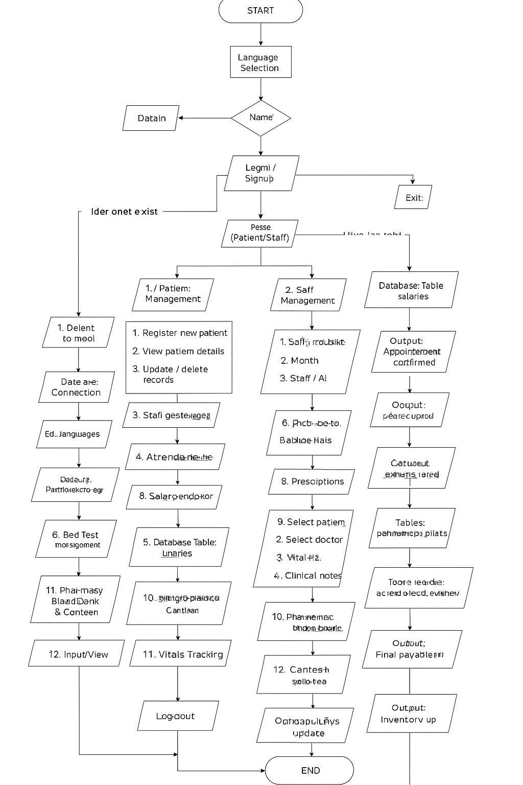

CODE
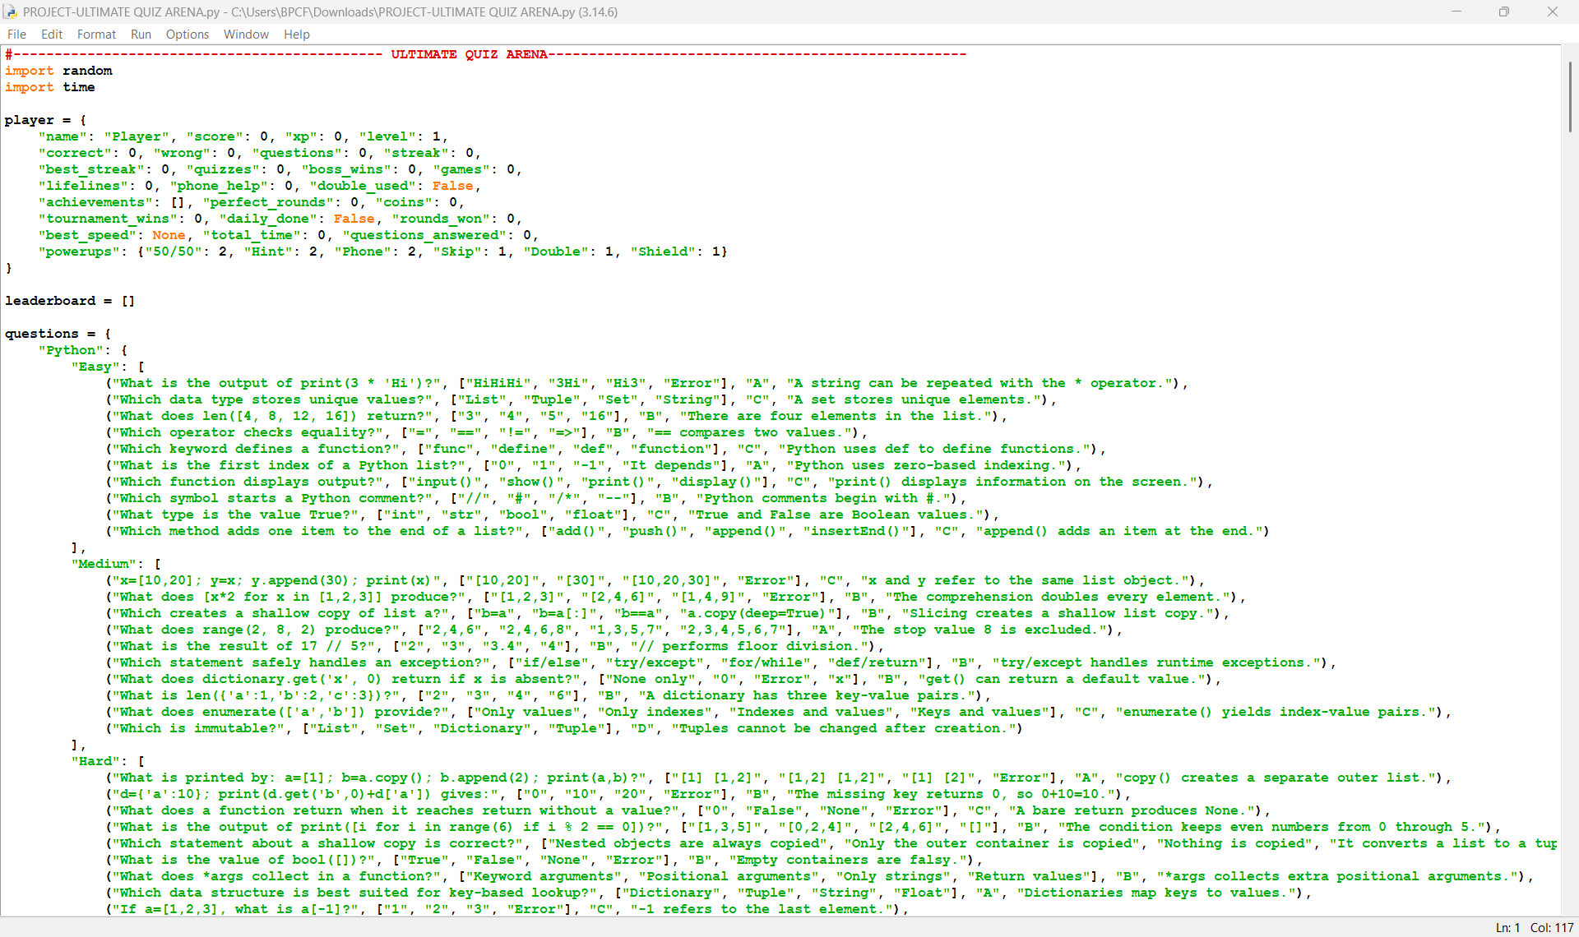
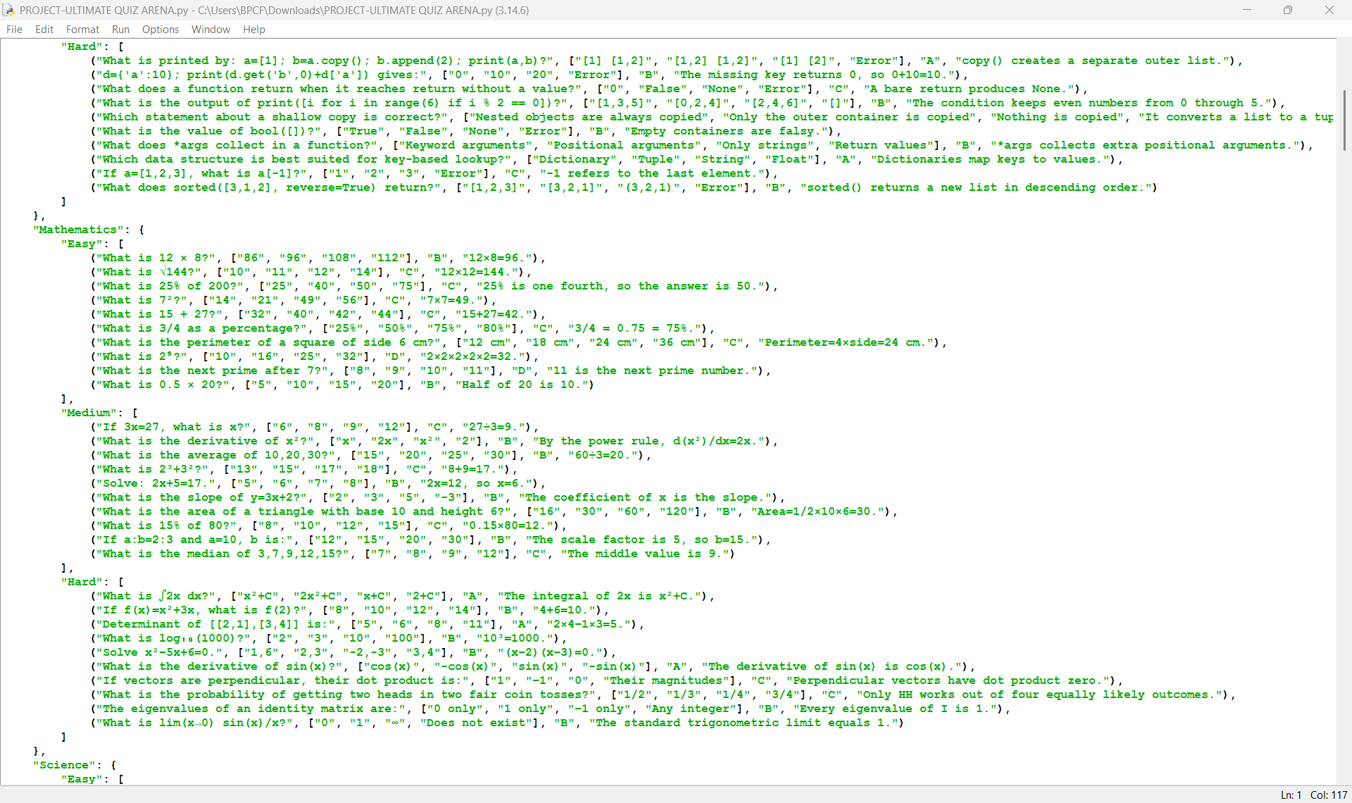
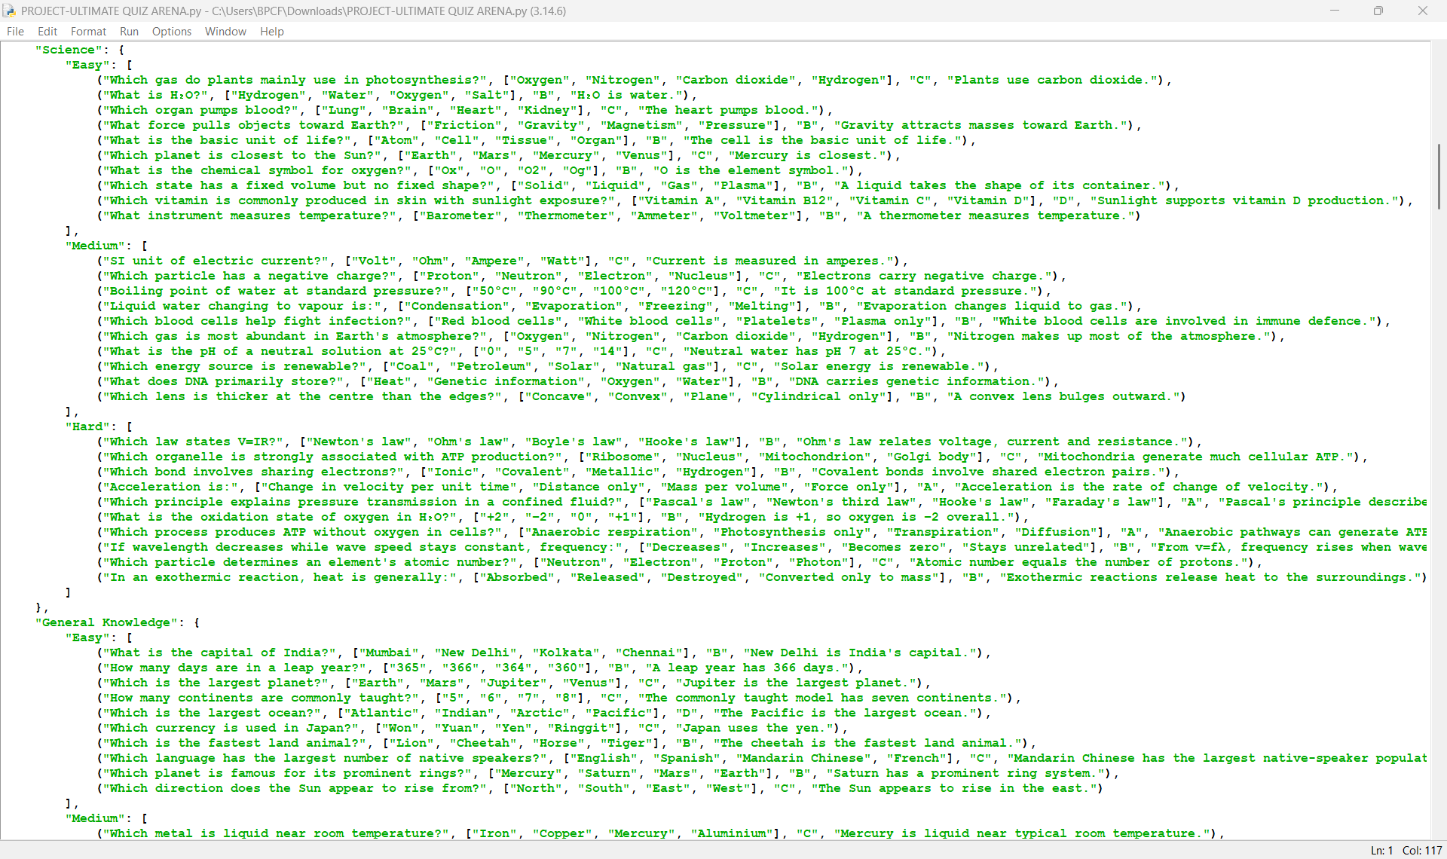
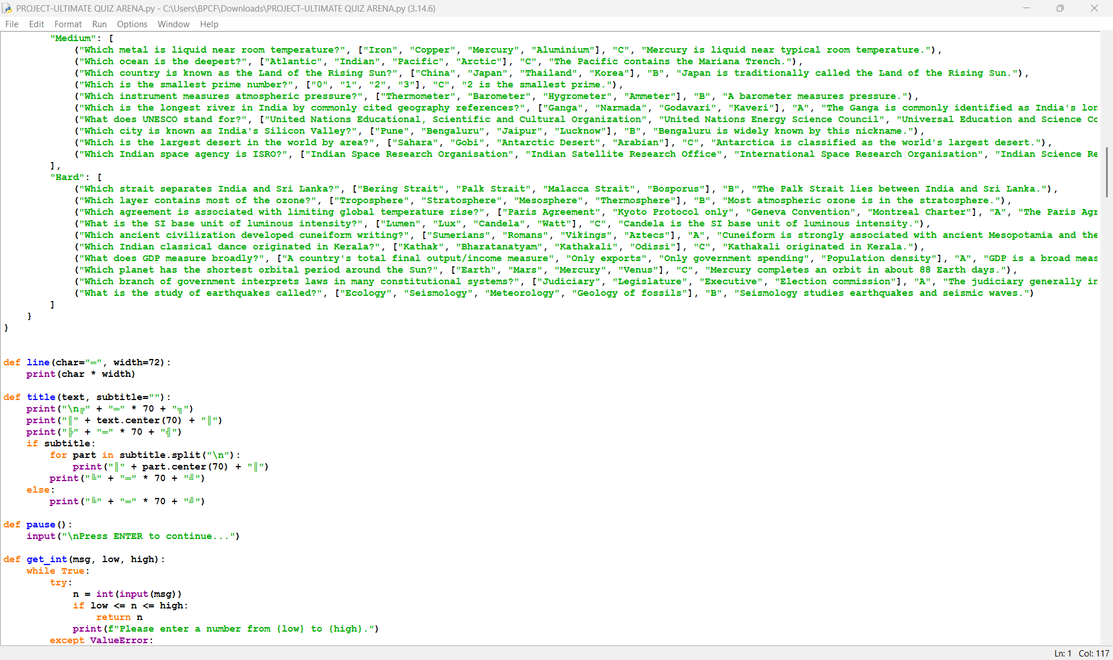
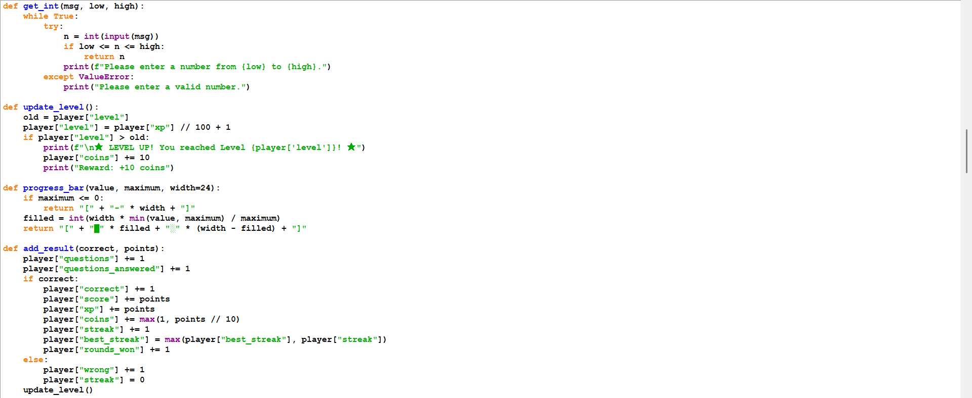
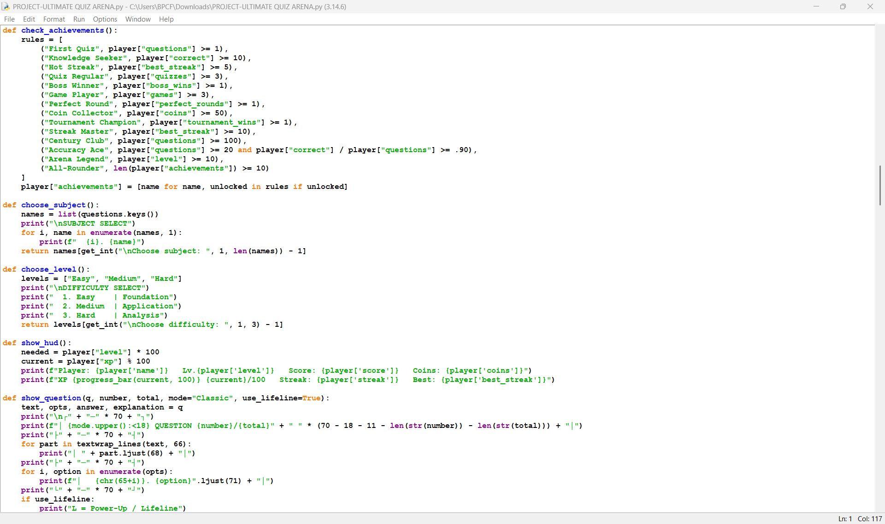
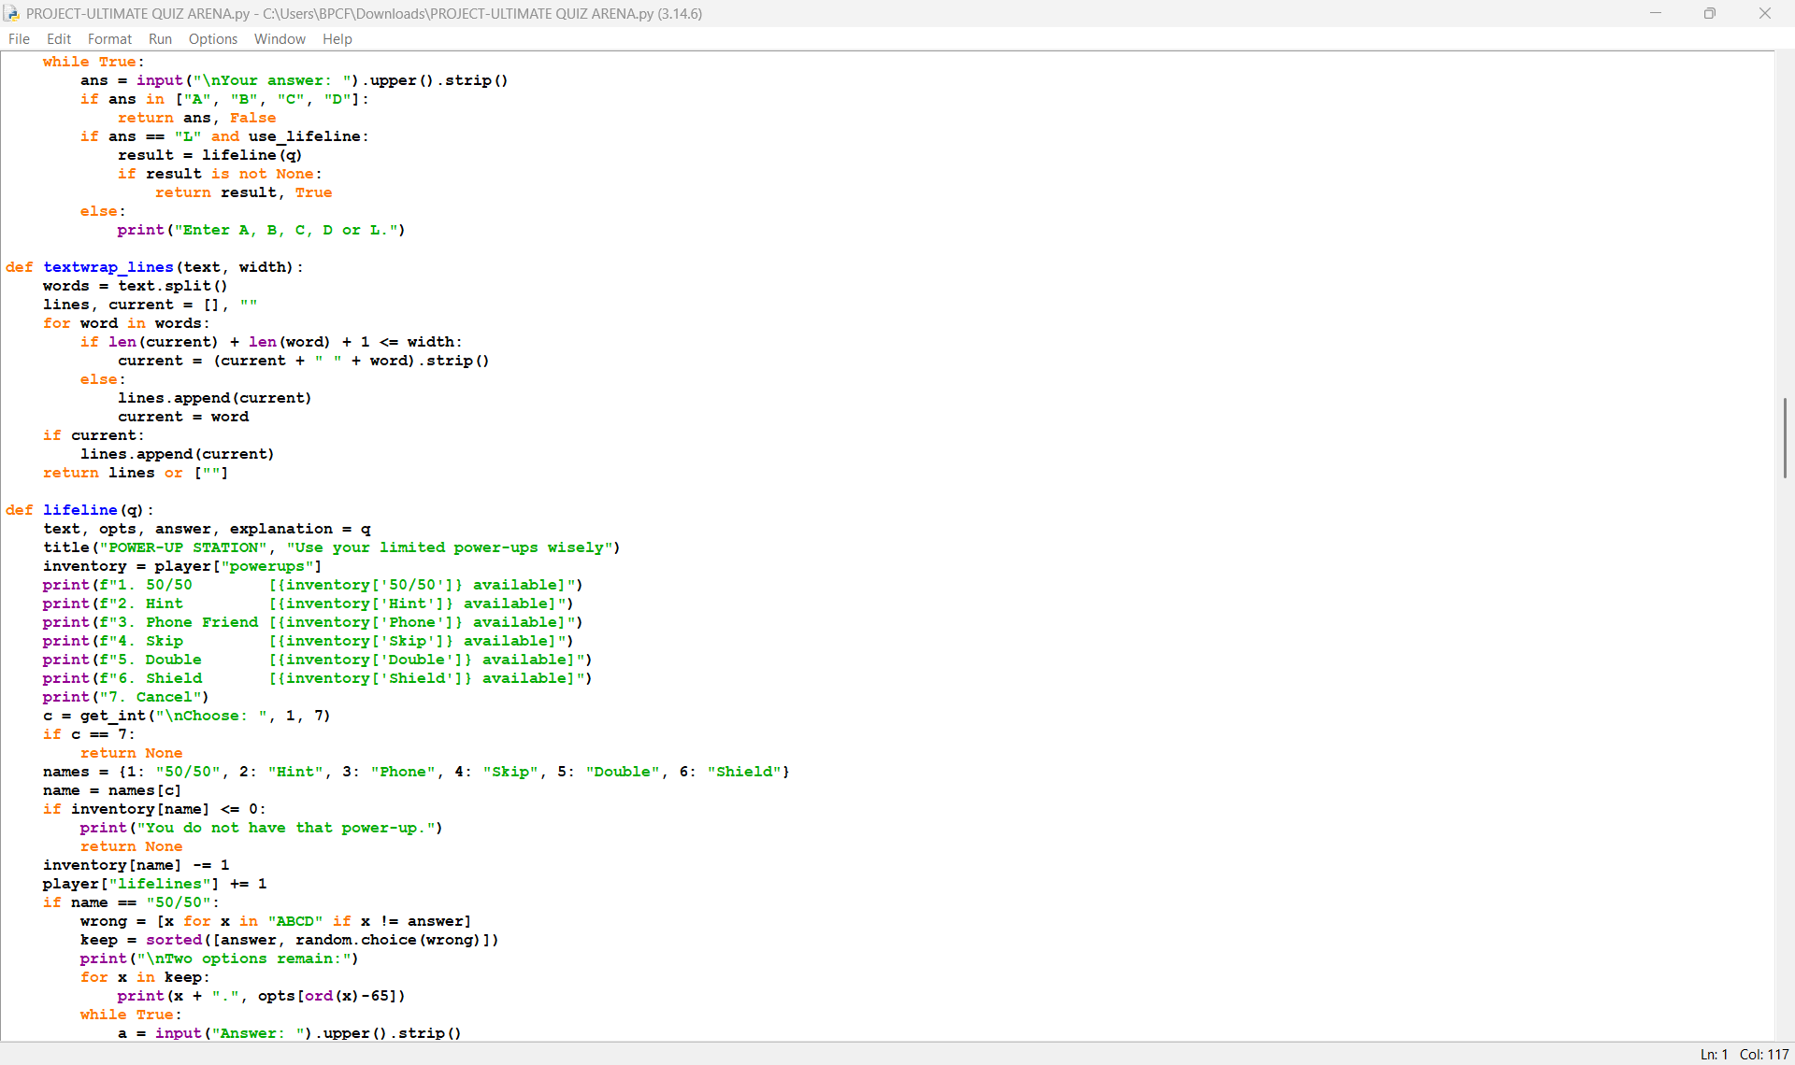
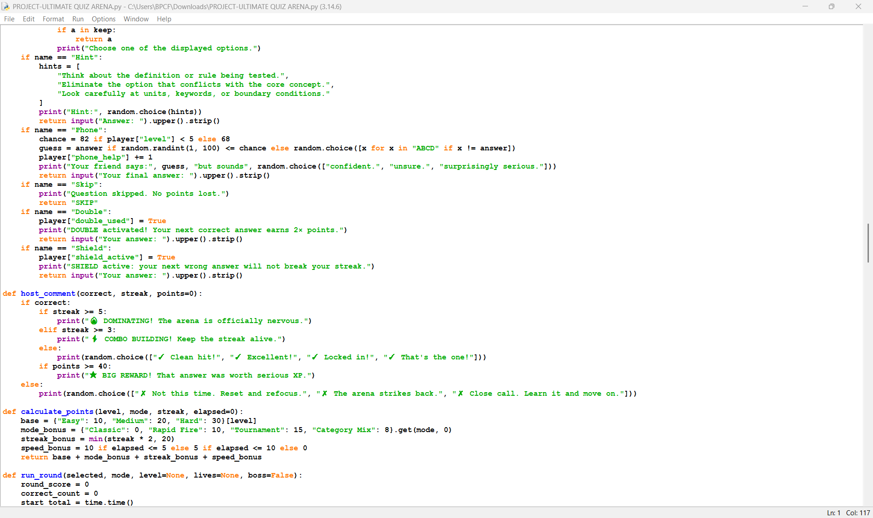
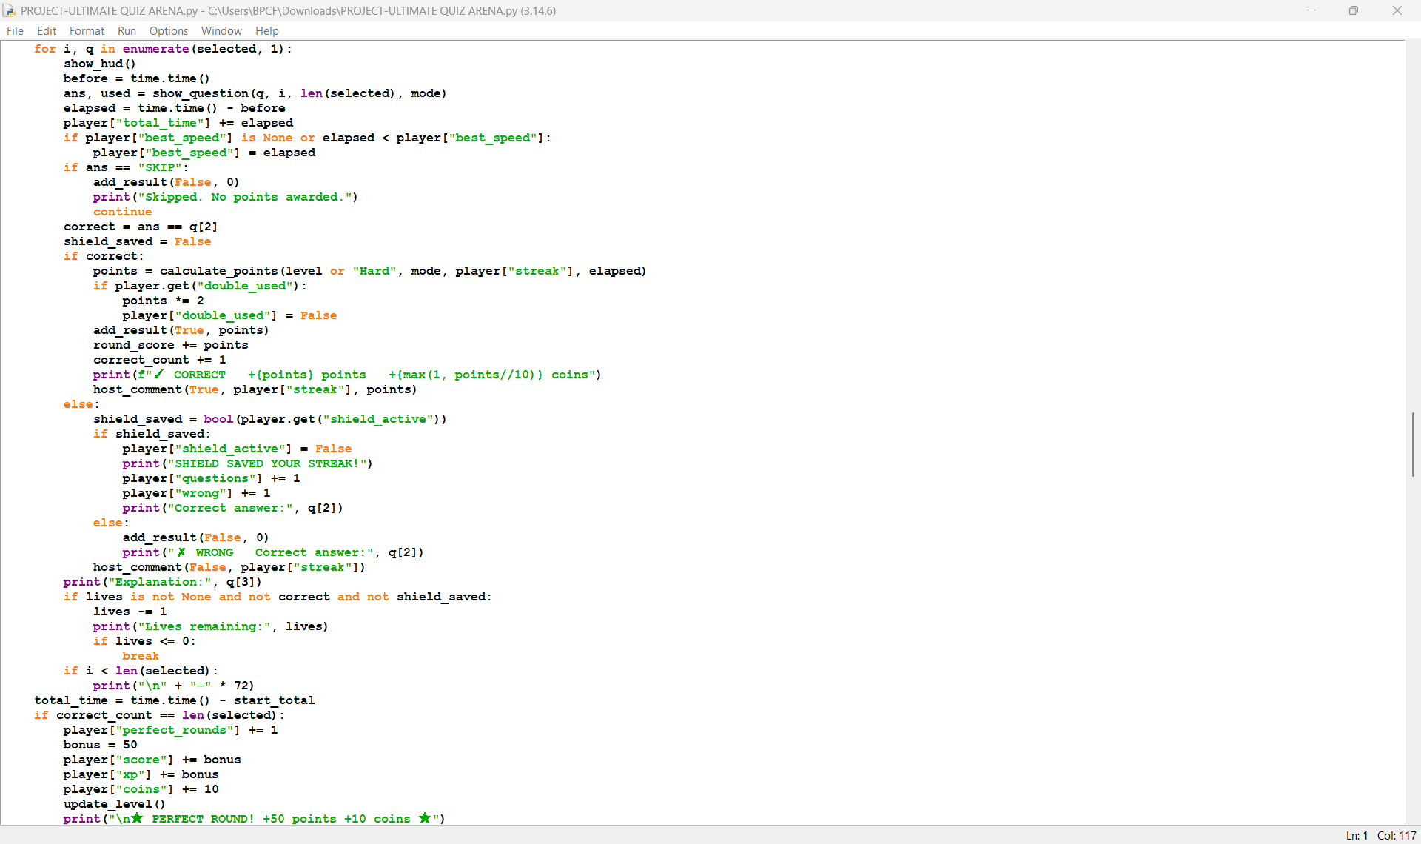
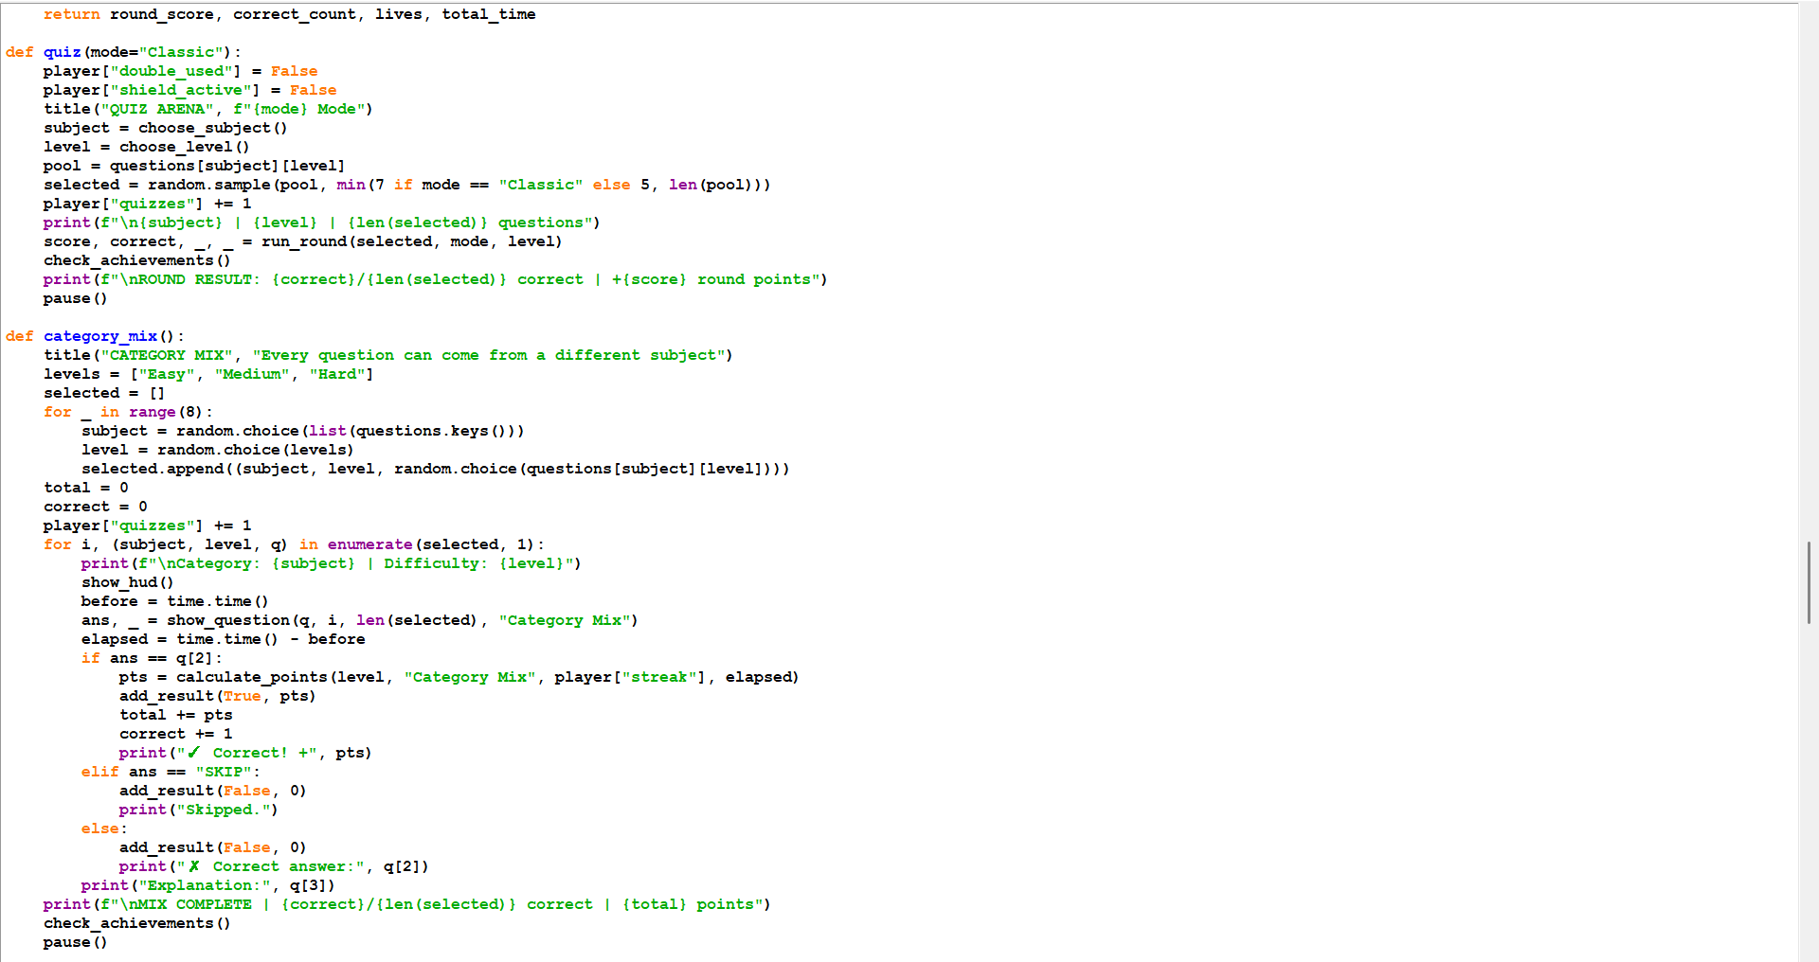
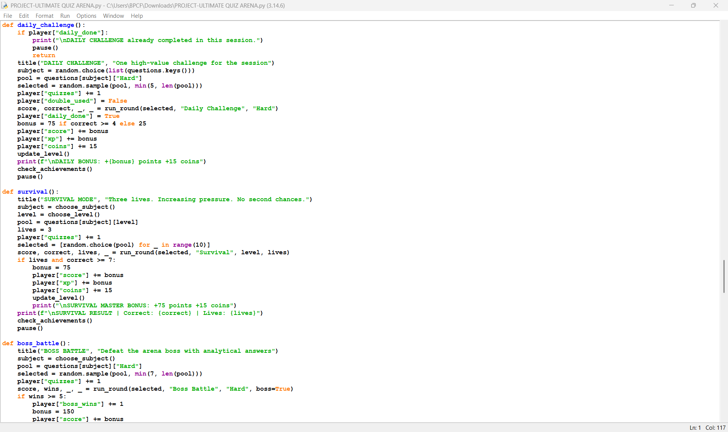
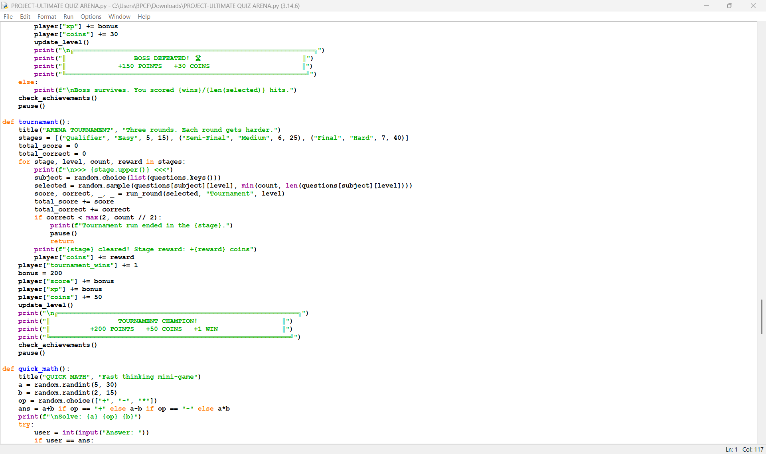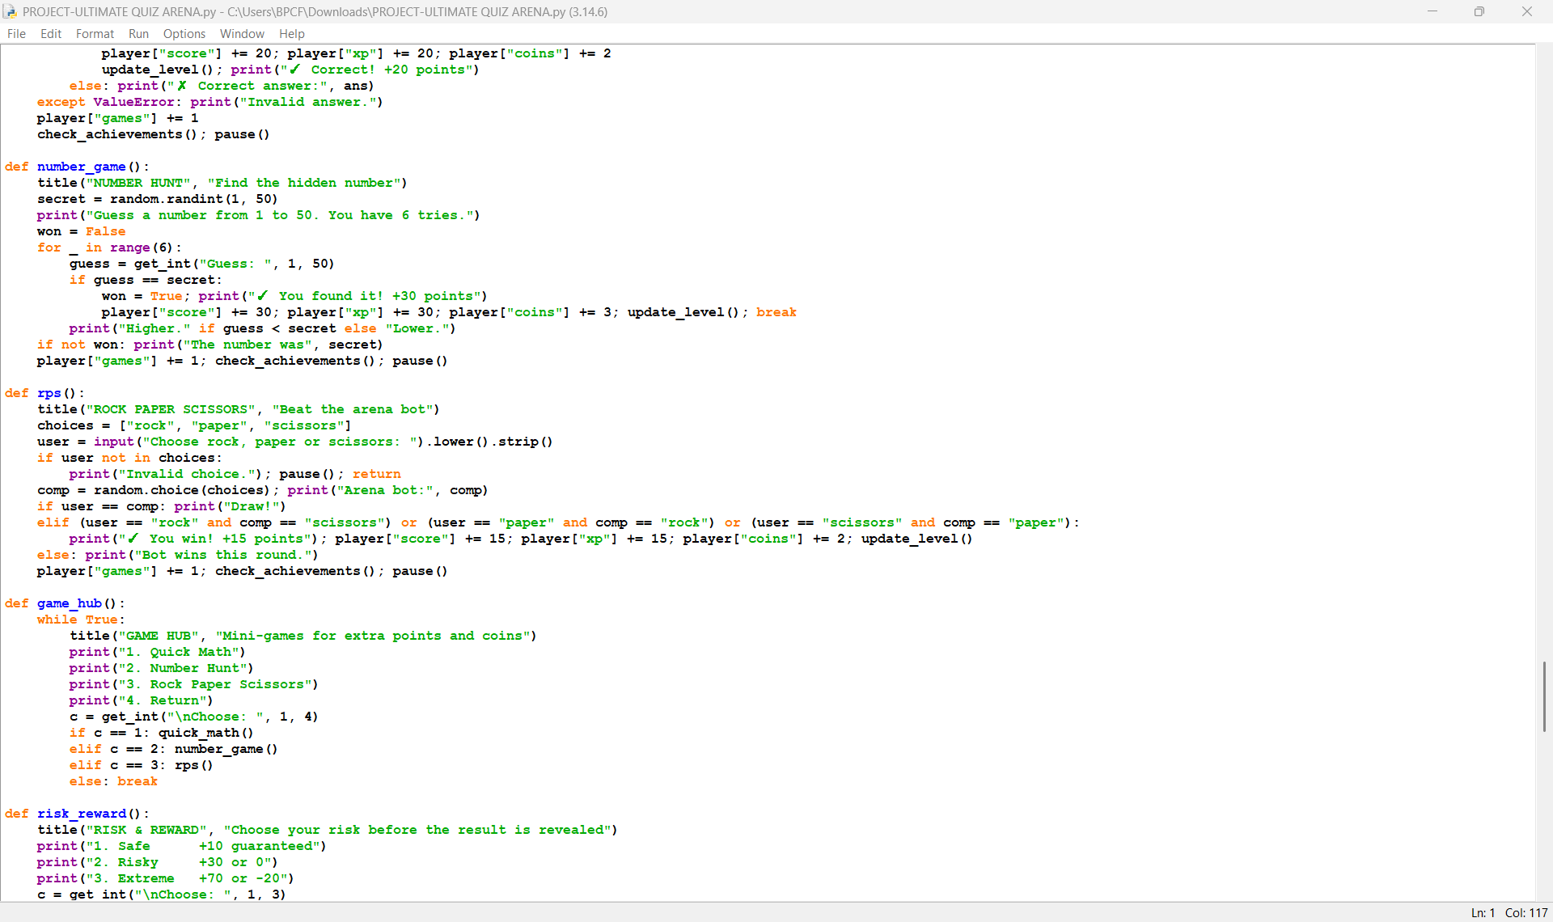
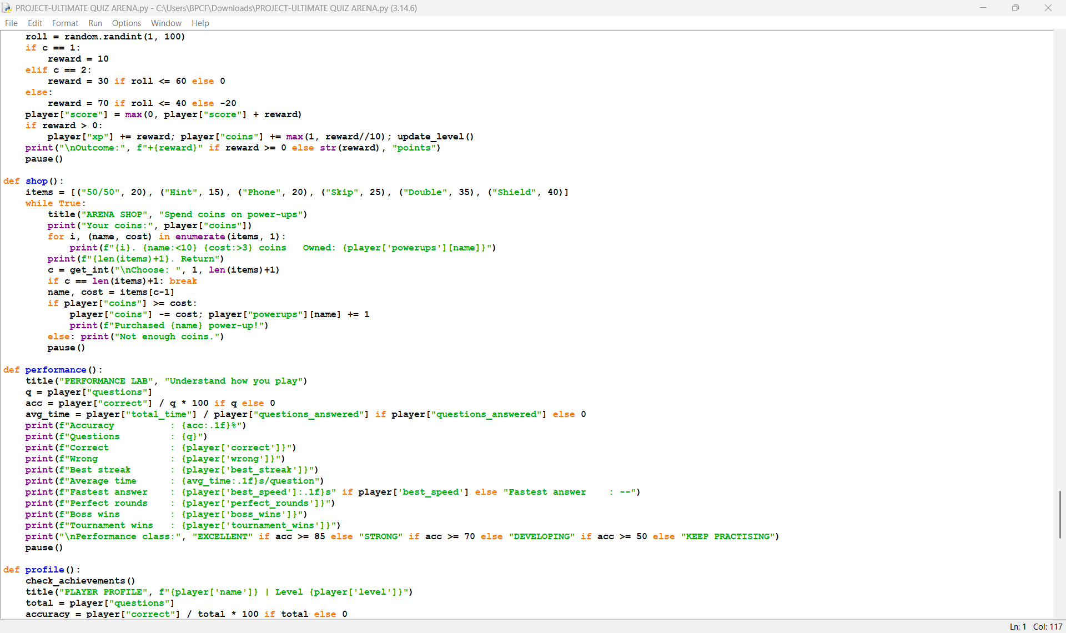
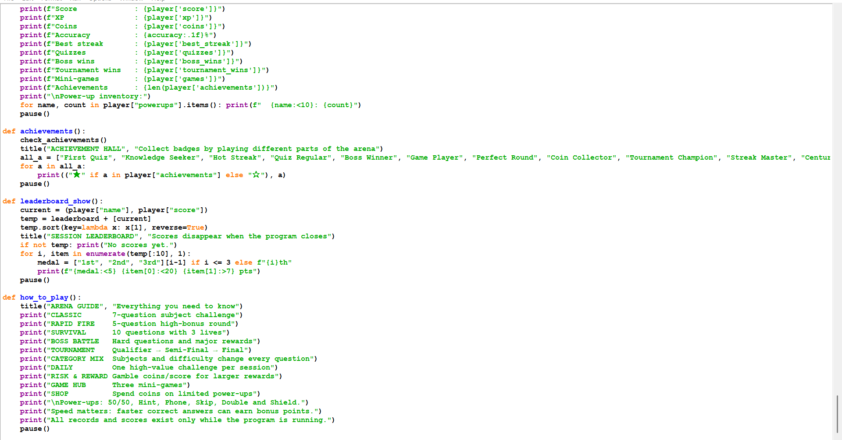
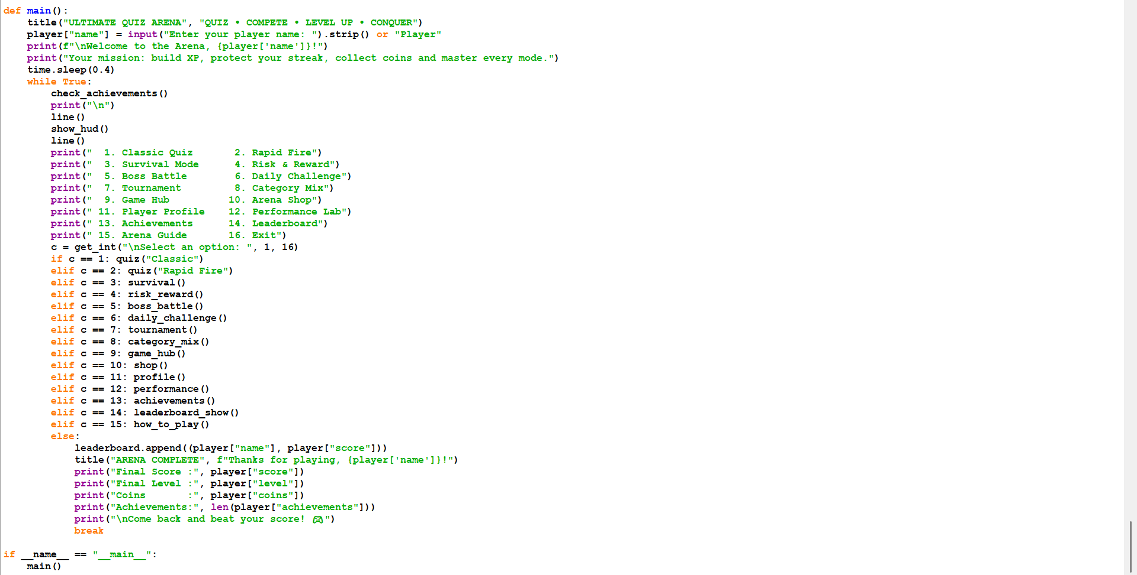

OUTPUT
- Quiz Modes
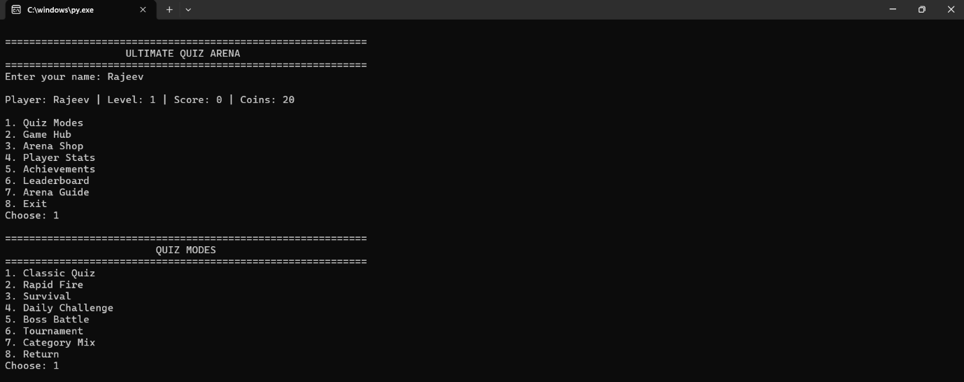

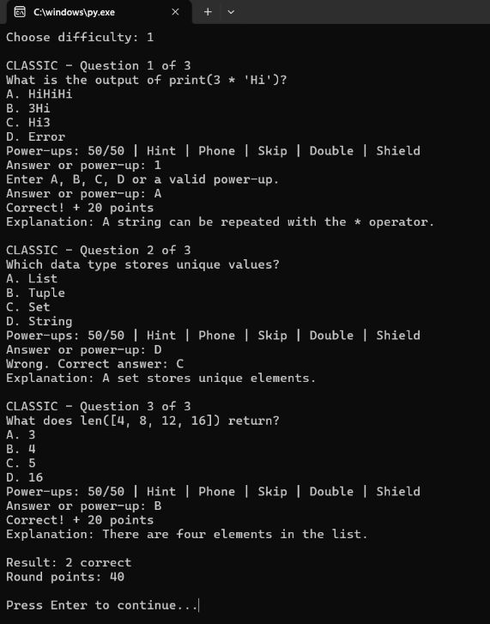
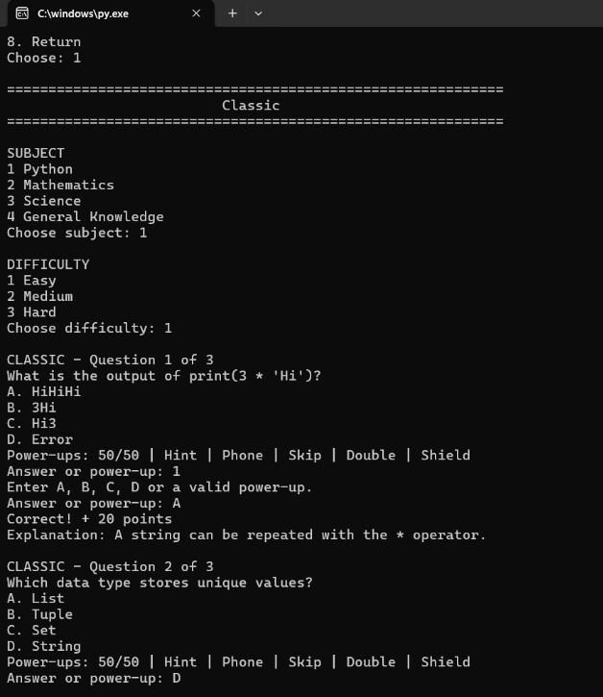
- Quiz Mode – Classic

- Quiz Mode – Rapid Fire
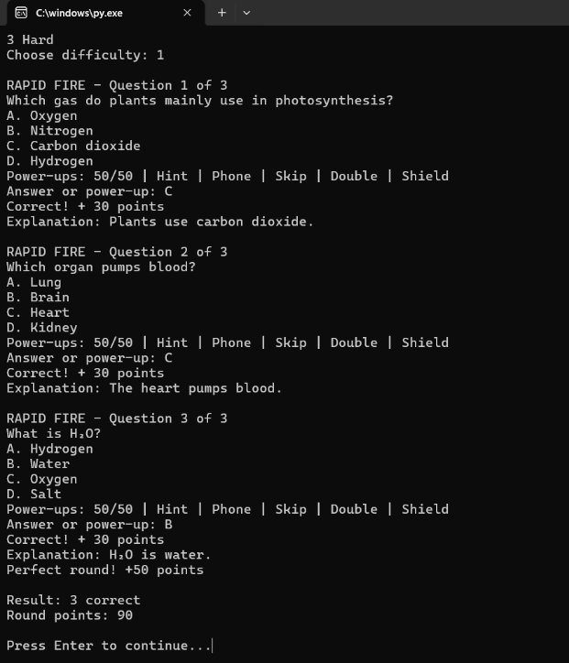
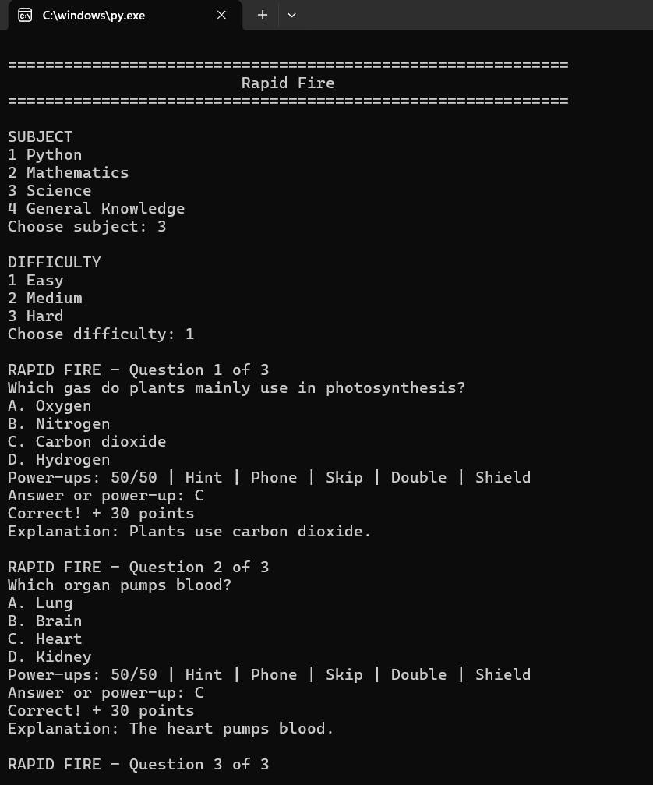
- Quiz Mode - Survival
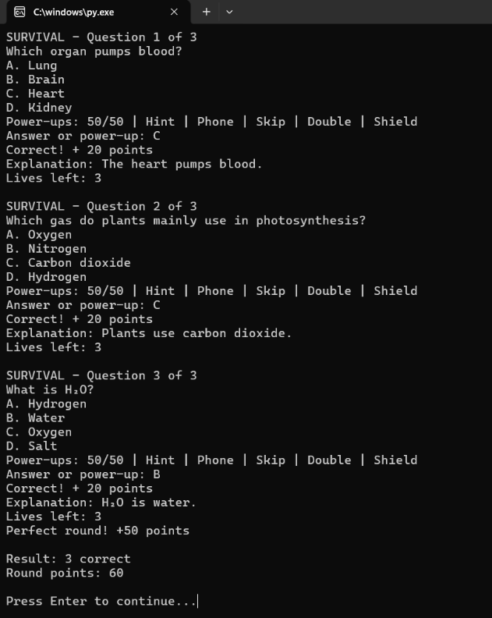
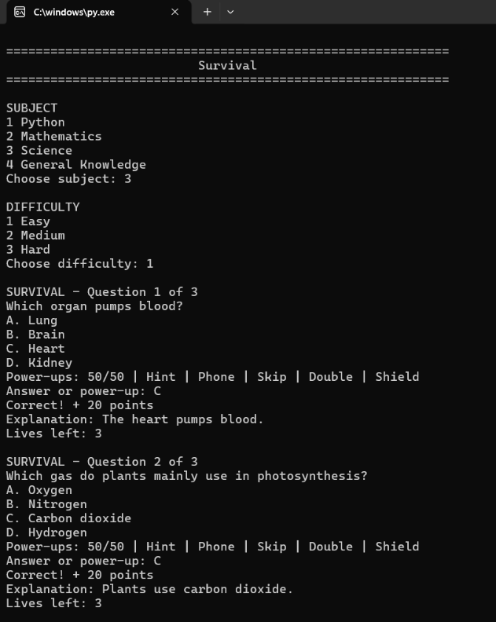

- Quiz Mode – Daily Challenge
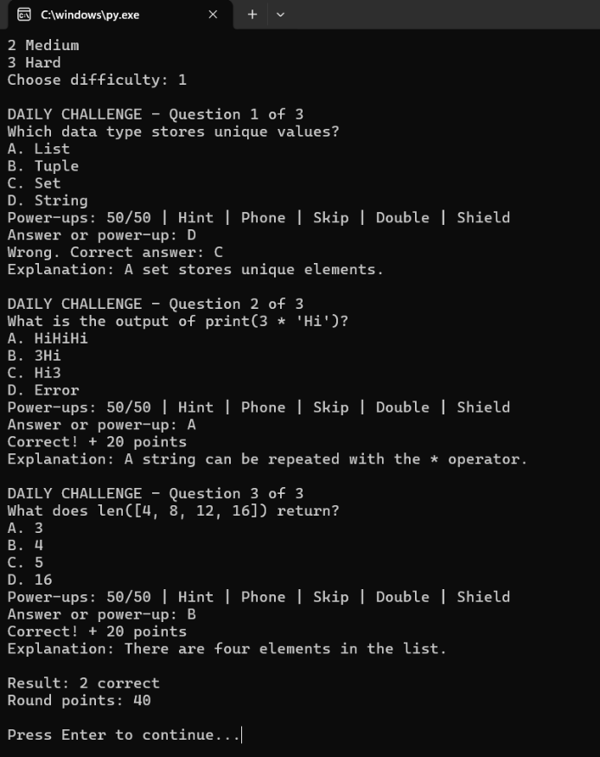
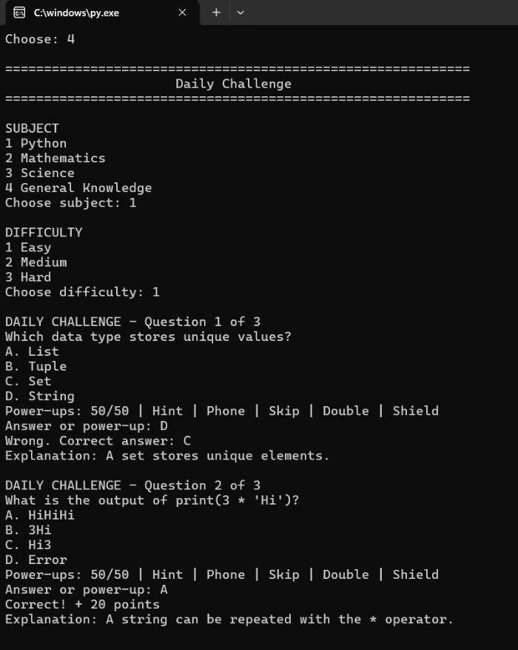

- Quiz Mode – Boss Battle
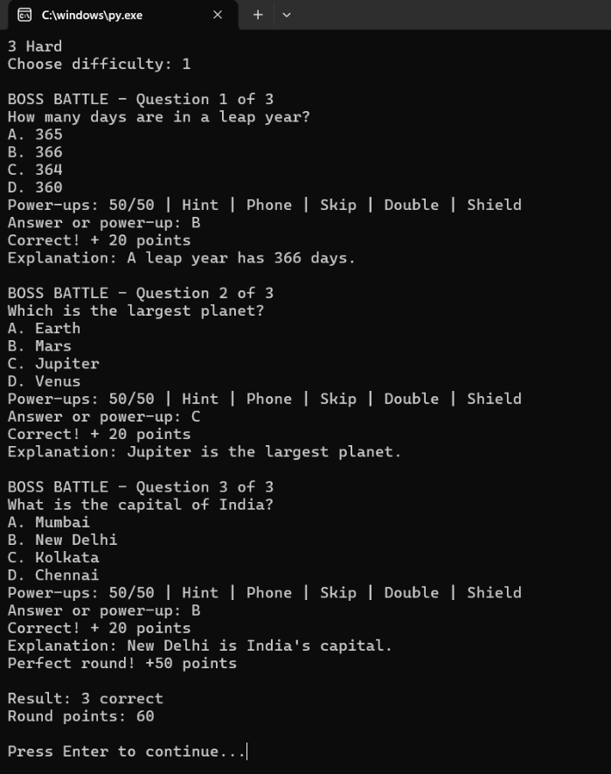
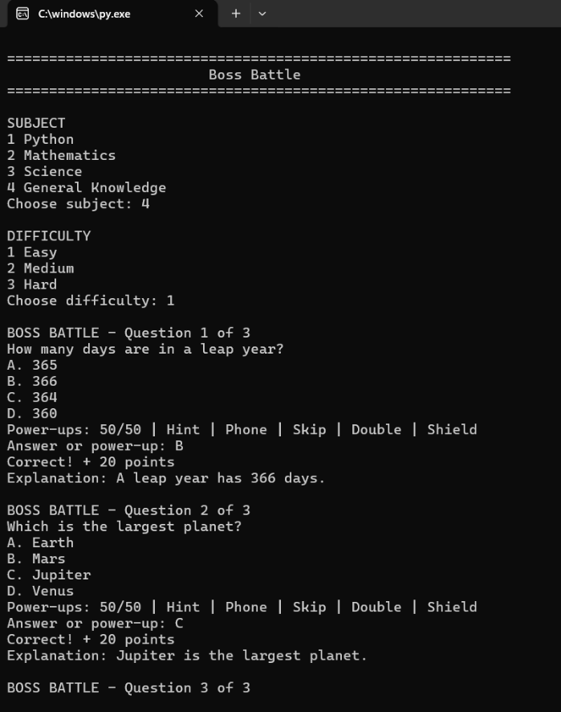

- Quiz Mode – Tournament
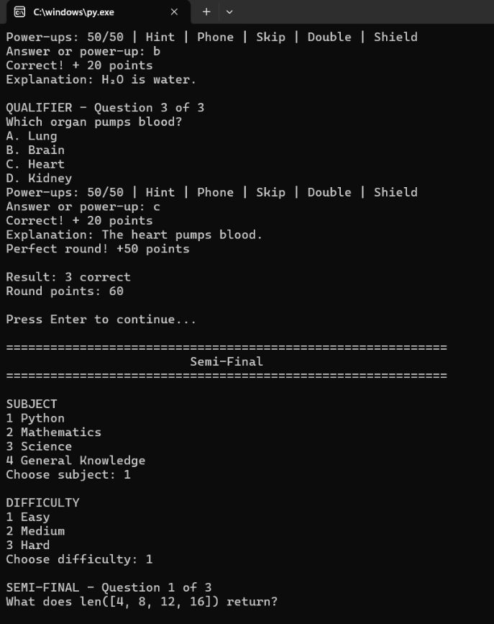
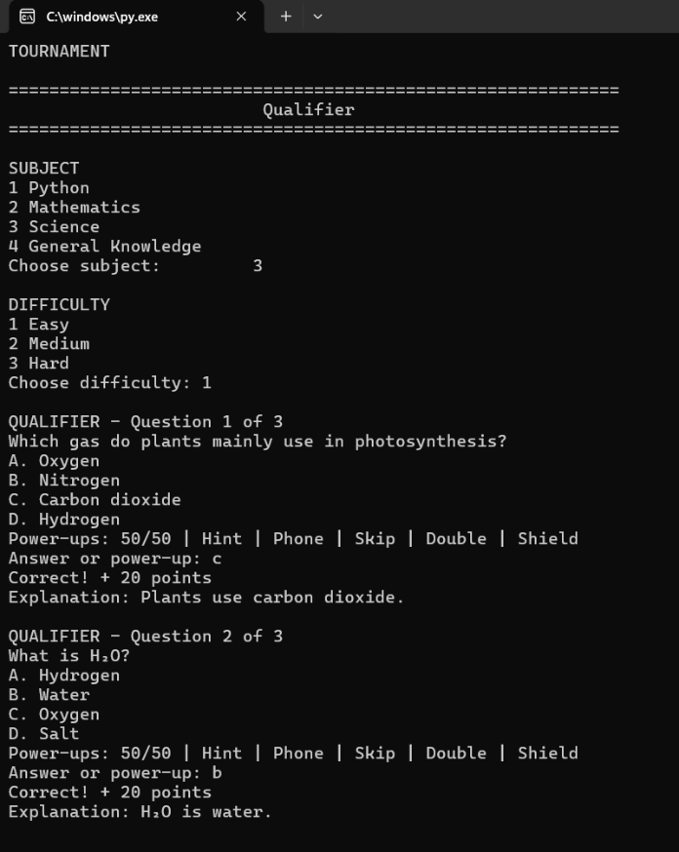

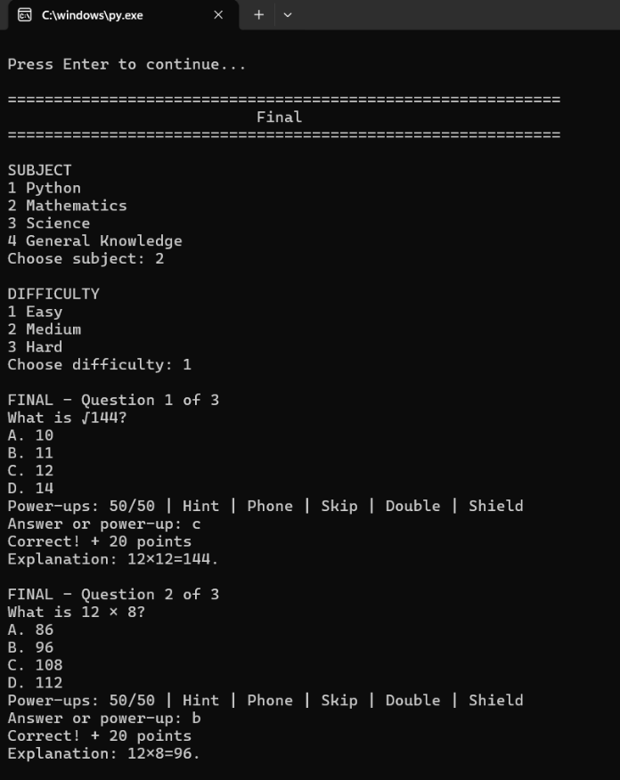
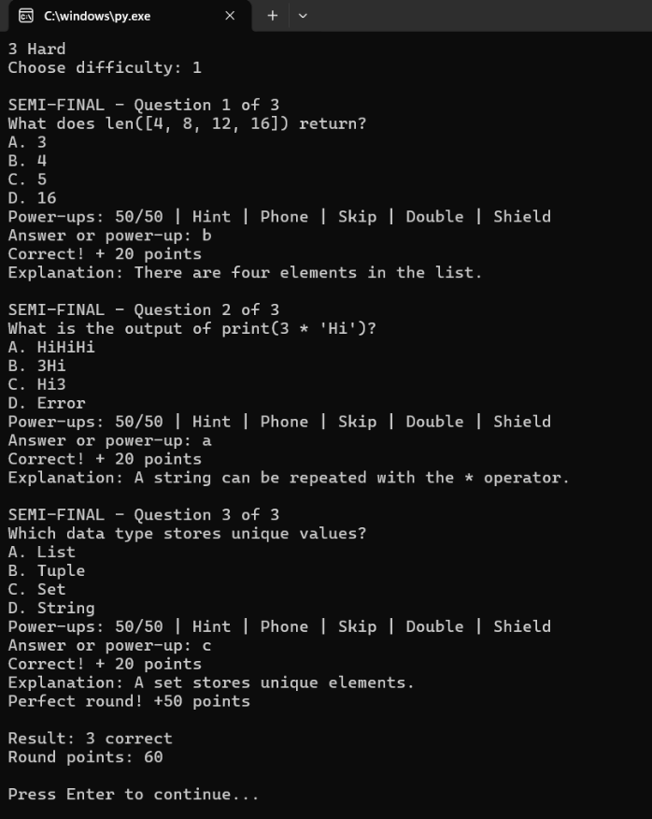

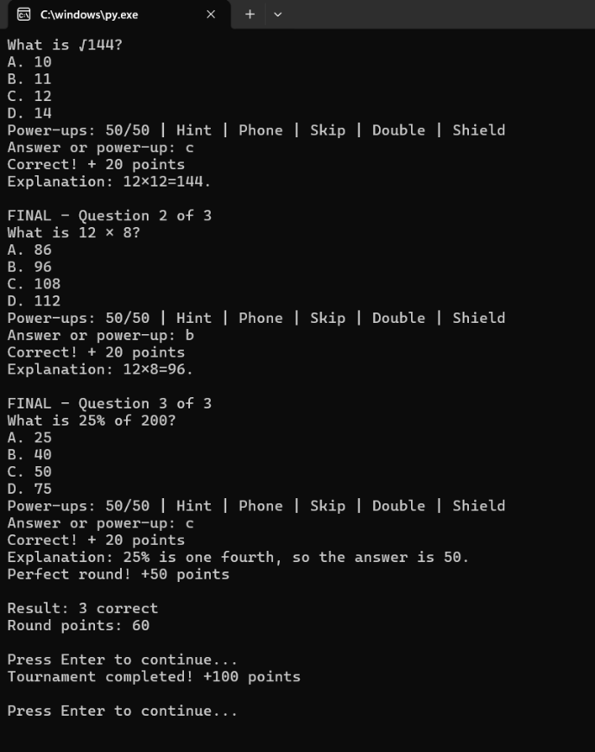

- Quiz Mode – Category Mix
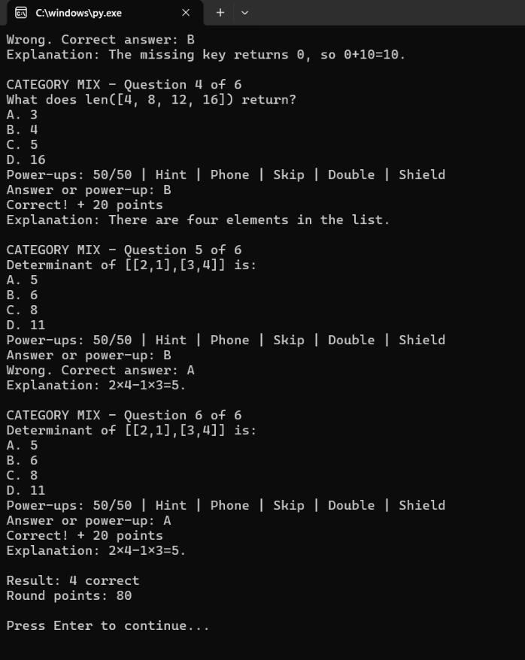
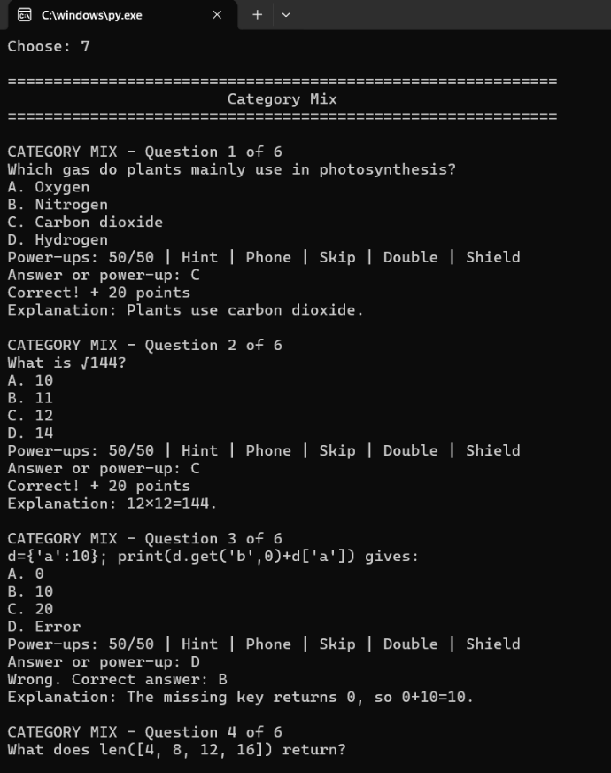

- Game Hub
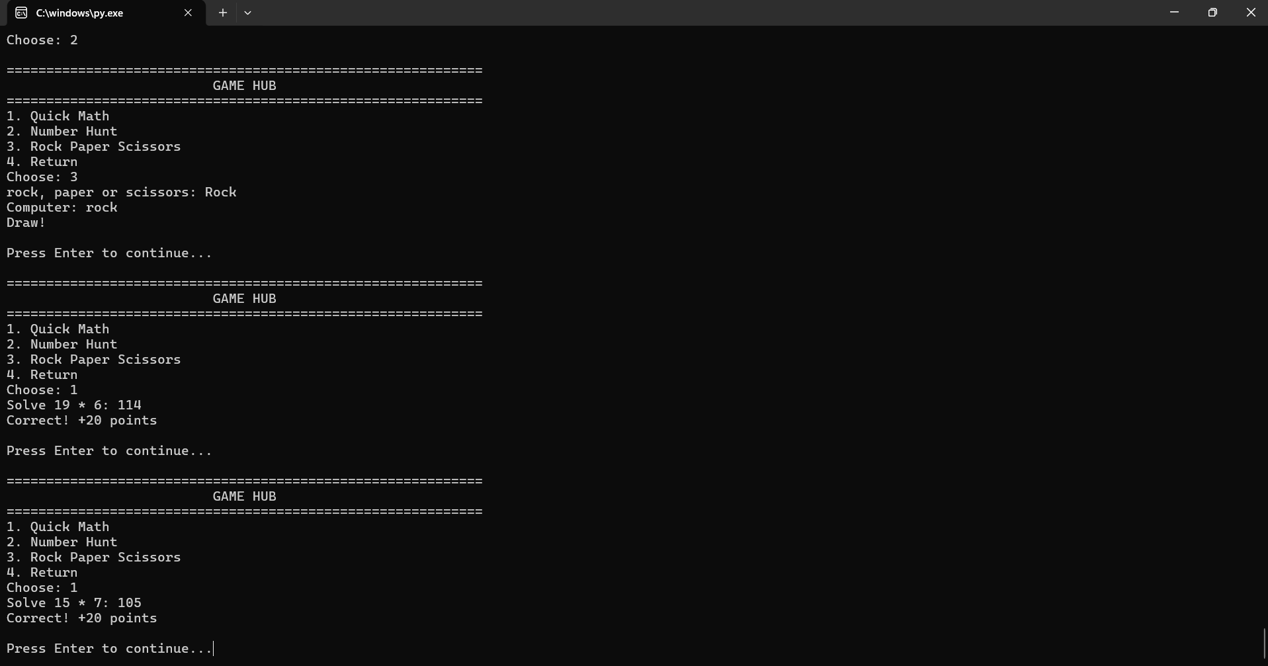
- Arena Shop
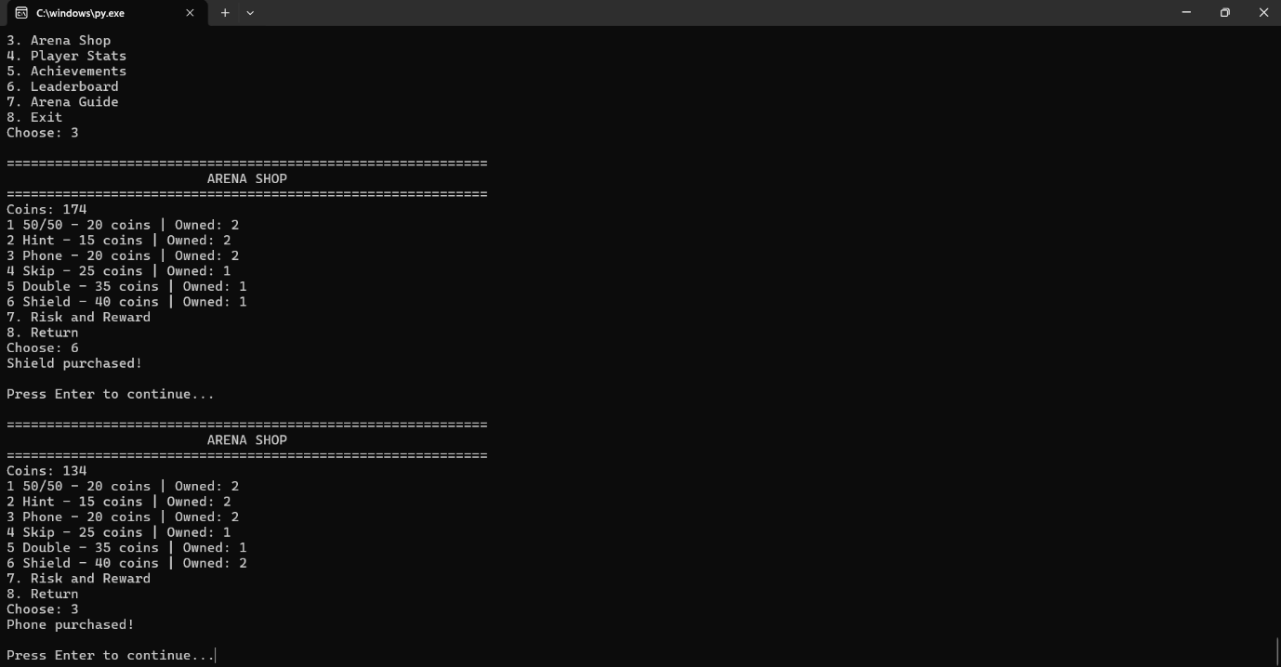

- Player Stats
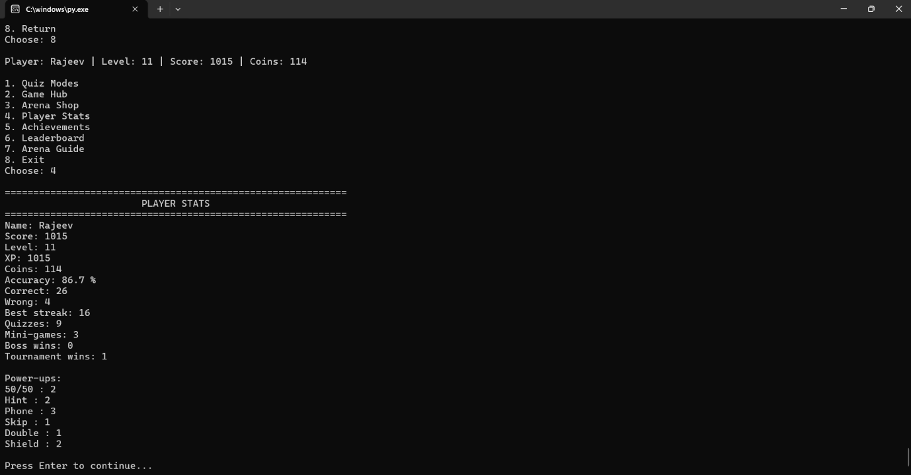

- Achievements & Leaderboard
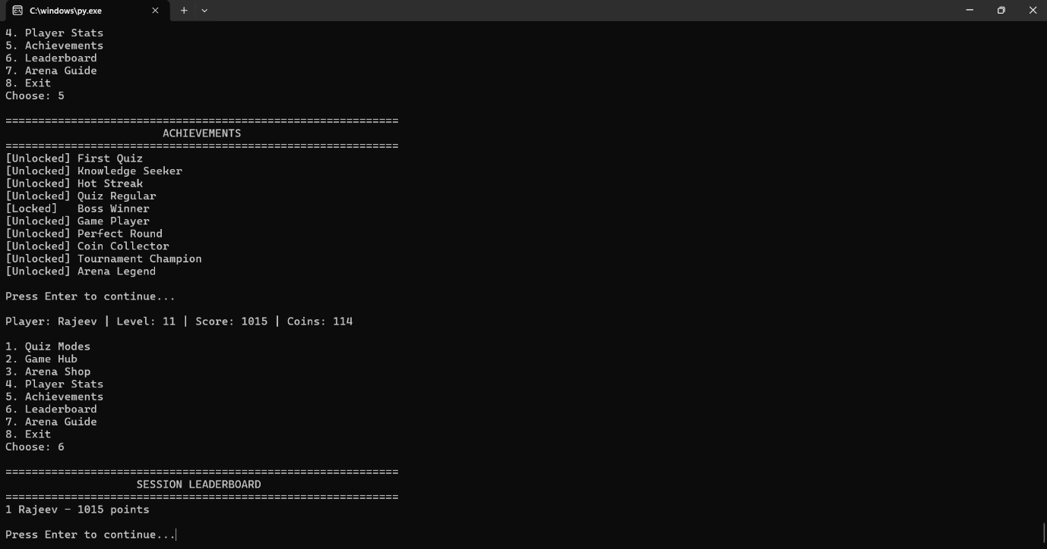

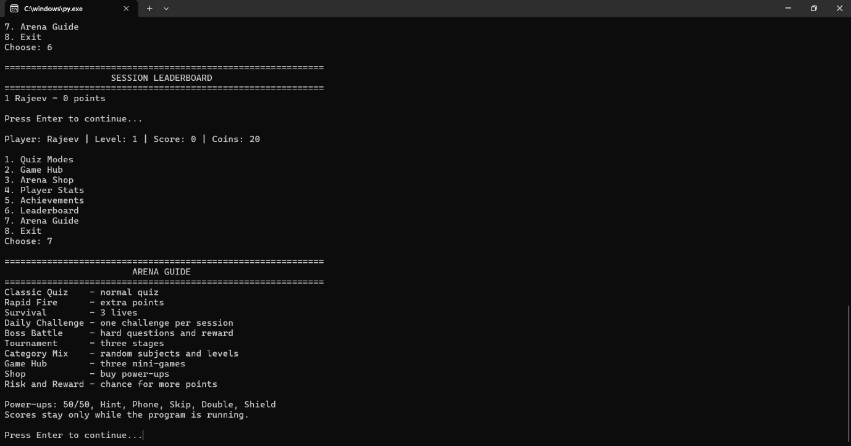
- Arena Guide

BIBLIOGRAPHY
- Python Software Foundation, Python 3 Documentation — reference for Python programming concepts and built-in functions.
- Python Software Foundation- random module
- Python Software Foundation, Python Tutorial — reference for functions, loops, lists, dictionaries, and conditional statements.
- Project Documentation and Program Output — reference for the features and working of the ultimate quiz arena system

